**9 SCIENCE 2016**

### BIOLOGY TEST ONE

Name: ____________________ Teacher: ___________________ Mark: /63

**Percentage: %**

**SECTION A: MULTIPLE CHOICE (15 marks)**

**Please answer on the multiple choice answer grid below.**

1. A B C D 10. A B C D

2. A B C D 11. A B C D

3. A B C D 12. A B C D

4. A B C D 13. A B C D

5. A B C D 14. A B C D

6. A B C D 15. A B C D

7. A B C D

8. A B C D

9. A B C D

**1.** Choose the incorrect statement:

(a) In many people the left hemisphere of the brain is responsible for language and logical thinking.

(b) The left side of the brain controls the right side of the body.

(c) The cerebellum has two hemispheres.

(d) The function of the folds of the brain is to increase surface area.

Answer questions 2 and 3 based on the diagram below.

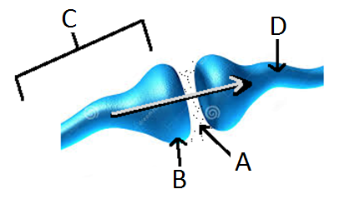

**2.** The diagram shows:

(a) A synapse between two neurones.

(b) A synapsis between two nerves.

(c) A knee joint.

(d) A synopsis between two neurones.

**3.** Label ‘A’ in the diagram refers to:

(a) A vacuum

(b) The neurotransmitter.

(c) The axon.

(d) The neuron.

**4.** Choose the correct definition for ‘target cells.’

(a) The cells that hormones act on.

(b) The cells that secrete hormones.

(c) Endocrine glands.

(d) The cells that enzymes act on.

**5.** Which of the following matches the sense with its correct receptor?

|  |  |  |
| --- | --- | --- |
| **Select from** | **Sense** | **Receptor** |
| (a) | Sight | Thermoreceptor |
| (b) | Smell | Photoreceptor |
| (c) | Taste | Chemoreceptor |
| (d) | Hearing | Olphactoreceptor |

**6.** Select the incorrect statement below.

(a) Nerve impulses can only travel in one direction.

(b) Nerve impulses are electrical messages carried by a nerve cell.

(c) The nervous system is made up of hundreds of nerve cells.

(d) Electrical messages are also known as nerve impulses.

**7.** A receptor is a specialised nerve. The main function of the receptors is:

1. Send messages from the brain to the muscles
2. Carry out a response
3. Send messages to the central nervous system from an organ
4. Detect a stimulus

**8.** Identify the activity that would be difficult after sustaining damage to the cerebellum.

1. Speech
2. Walking
3. Breathing
4. Intellectual thought
5. **9.** The diagram illustrates the body’s response to a sudden rise in blood glucose level (BGL). Identifythe INCORRECTstatement.
6. 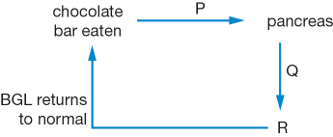

(a) R represents the liver.

(b) P represents a rise in blood glucose level.

(c) Q represents a rise in insulin levels in the blood.

(d) Glucagon is produced at R to reduce the blood glucose level.

1. **10.** Identify the part of the neurone labelled 1 in the diagram.
2. 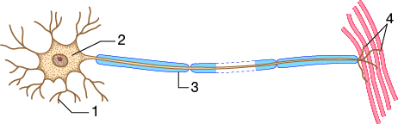
3. axon
4. dendrite
5. knob
6. cell body
7. **11.** Name two parts of the autonomic nervous system.
8. central nervous system and parasympathetic nervous system
9. sympathetic and parasympathetic nervous system
10. central nervous system and peripheral nervous system
11. peripheral nervous system and

**12.** Describe the relationship between the hypothalamus and the pituitary gland.

(a) The pituitary is called the “master gland”. The hypothalamus responds to messages from the pituitary gland.

(b) The hypothalamus secretes hormones that act on the pituitary gland which is also known as the “master gland”.

(c) The hypothalamus is part of the brain and the pituitary gland is located in front of the trachea in the neck.

(d) The hypothalamus constantly checks the conditions within the organs and systems of the body. The pituitary gland checks the activity of the brain.

**13.** If you become frightened by something adrenalin is usually released. Identify the **incorrect** effect of adrenalin on your body.

(a) Increased heart rate to pump more blood around your body

(b) Expanded blood vessels to allow more blood to flow through them

(c) Dilated air-ways to allow more air to be taken up by vital organs

(d) Inhibited release of insulin to allow more glucose to remain in the blood stream

**14.** Name the hormone that controls the amount of water in the blood.

(a) Thyroxine

(b) Cortisol

(c) Antidiuretic hormone

(d) Insulin

**15.** Identify the **correct** definition of “homeostasis”

(a) The maintenance of a constant internal environment

(b) The ability to react to changes in the internal environment

(c) The releasing of hormones that react to certain stimuli

(d) A pair of hormones that work together and react in opposite ways

**SECTION B: SHORT ANSWER (48 marks)**

**1a.** Label the diagram below. (7 marks)

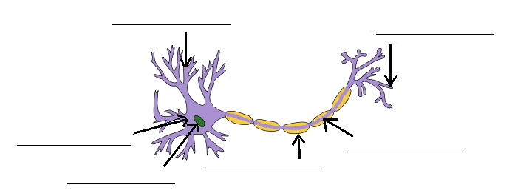

**b.** State the type of neuron shown in the diagram above.__________________________________

**2a.** Label the diagram below. (7 marks)

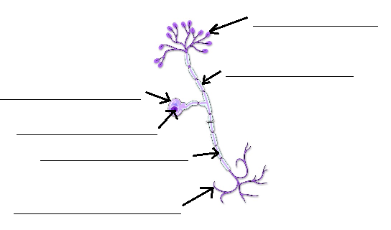

**b.** State the type of neuron shown in the diagram above.__________________________________

**3.** State the main structural difference between motor neurones and sensory neurones. (1 mark)

_____________________________________________________________________________________

_______________________________________________________________________________________________________________________________________________________________________________________________________________________________________________________________

**4.** Explain the process occurring in the diagram below (mention the substances that the secreting cell releases).(4 marks)

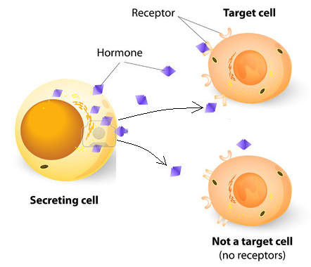

_____________________________________________________________________________________

_____________________________________________________________________________________

_____________________________________________________________________________________

_____________________________________________________________________________________

_____________________________________________________________________________________

_____________________________________________________________________________________

_____________________________________________________________________________________

_____________________________________________________________________________________

_____________________________________________________________________________________

_____________________________________________________________________________________

**5.** Label the diagram below. (3 marks)

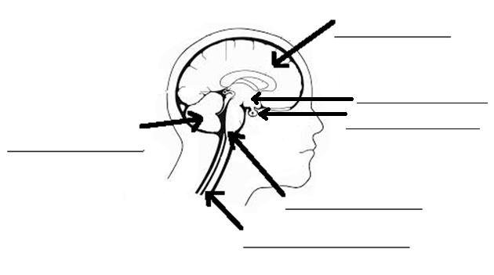

**6.** Fill in the blanks on the diagram below, please use the full names not initials or abbreviations (6 marks)

**The Nervous System**

**_______________________________________**

**_______________________________________**

Made up of the brain and spinal cord.

**__________________________________________**

**___________________________________________**

Carries messages from the CNS to the rest of the body

**___________________________________________________**

**___________________________________________________**

Part of the nervous system that:

____________________________________________________

____________________________________________________

E.g.: touch, smell, taste, hearing, sight.

**_________________________________________**

**__________________________________________**

Controls unconscious activities in your body

**___________________________________________**

**___________________________________________**

Slows down the functions of the body

One function this system has is to:

___________________________________________

___________________________________________

___________________________________________

___________________________________________

**___________________________________________**

**___________________________________________**

Speeds up the functions of the body

One function this system has is to:

___________________________________________

___________________________________________

___________________________________________

___________________________________________

**7.** Fill in the missing words below. (2 marks)

The endocrine system is controlled by the _____________________ gland. This gland responds to _____________________ released by the hypothalamus. The hypothalamus’ role is to monitor the internal environment and maintain ________________________. It is also the link between the endocrine and ________________________ systems.

**8.** Describe the function of the myelin sheath. (2 marks)

_____________________________________________________________________________________

_____________________________________________________________________________________

**9.** Write a definition for ‘effectors’. (2 marks)

_____________________________________________________________________________________

_____________________________________________________________________________________

_____________________________________________________________________________________

**10.** Fill in the table below: (8 marks)

|  |  |  |
| --- | --- | --- |
| Hormone | Function | Produced by |
|  |  | Ovaries |
|  | Lowers blood glucose levels |  |
| Thyroxin |  |  |
|  | Development of secondary sex characteristics in males |  |

**11.** Two students were testing the effectiveness of an enzyme on breaking down proteins into amino acids. When protein is broken down into amino acids it turns clear.

The students had two test tubes in a water bath (container with water). Both of the test tubes had some egg white (protein) in the bottom. One of the test tubes also had an enzyme called protease added to it. The test tubes were placed in a water bath and left there for 20 minutes.

They repeated the experiment three times. Their set up is shown below:

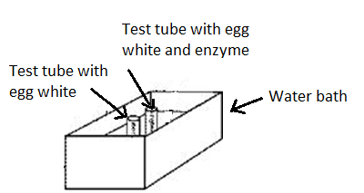

After 20 minutes they obtained the following results:

|  |  |  |
| --- | --- | --- |
| Trial | With enzyme | Without enzyme |
| 1 | Turned Clear | Remained white |
| 2 | Turned Clear | Remained white |
| 3 | Turned Clear | Remained white |

**a.** State the independent variable in this experiment. (1 mark)

_____________________________________________________________________________________

**b.** State the dependent variable in this experiment. (1 mark)

_____________________________________________________________________________________

**c.** List two variables that should be controlled. (2 marks)

_____________________________________________________________________________________

_____________________________________________________________________________________

**d.** Explain what they could conclude from the results they obtained. (2 marks)

_____________________________________________________________________________________

_____________________________________________________________________________________

_____________________________________________________________________________________

_____________________________________________________________________________________